Entryform
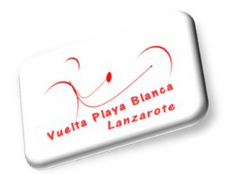

Please fill out in Capital Letters

Participants have to fill out the Form, than scan and send via E-Mail to vueltaplayablanca@gmail.com, or (for late entries) drop the filled Form at Hotel H10 Timanfaya Palace.
5. Salinas Race 15.Feb.2019 & 10. Vuelta Playa Blanca 16.Feb.2019

2 Races. 2x Points. 2x Pricemoney

Personal Data

Name:_____________________________________________________________________
Adress: ___________________________________________________________________
Telefon: ___________________________________________________________________
Email: _____________________________________________________________________
Date of Birth _______________________________
Nationality: __________________________________
Shirt Size ____________________________________

Category –please mark

MH 1 □ MH 2 □ MH 3 □ MH 4 □ MH 5 □ MH 0 □
WH 1 □ WH 2 □ WH 3 □ WH 4 □ WH 5 □ WH 0 □

Do you have Illnesses /Allergies or do you take Medication that our Doctor should be aware of? yes □ No □
If yes , what Type: ___________________

In Case of Emergency please leave a Phone Number: __________________________________
In Case of Emergency please leave the Name of a Contact Person:________________________

Where are you staying whilst you are on Lanzarote: _____________________

Entry deadline: January 31st, 2019.
Registration after the deadline takes +10€.

With my participation to an event of the European Handbike Circuit I acknowledge the liability exclusion of the EHF Committee or of involved third party for personal or material damage. I hereby certify that I have full knowledge of the risks involved in this event and that I am physically fit and I have sufficiently trained to participate. I am in possession of a license (national or International) for my sport and I have a medical certificate that authorizes me to do competition sports in handbike. Furthermore I do acknowledge that I have thoroughly read and understand the actual Rulebook of the UCI and EHC.
You're information will be handled with the biggest care. With participation you give the EHC approval to publish your results in the class where you started.

I understand and accept, that the Organization and Organizers of the Vuelta Playa Blanca can not be taken responsible for the unlikely Event of an Accident or Injury that may happen at the Vuelta Playa Blanca.

Signatur: _________________________________________________________________

Date&Place: ________________________________________________________________

Entry Fee 70€ (2 Races.2x Points.2x Pricemoney + Event Bike-jersey).

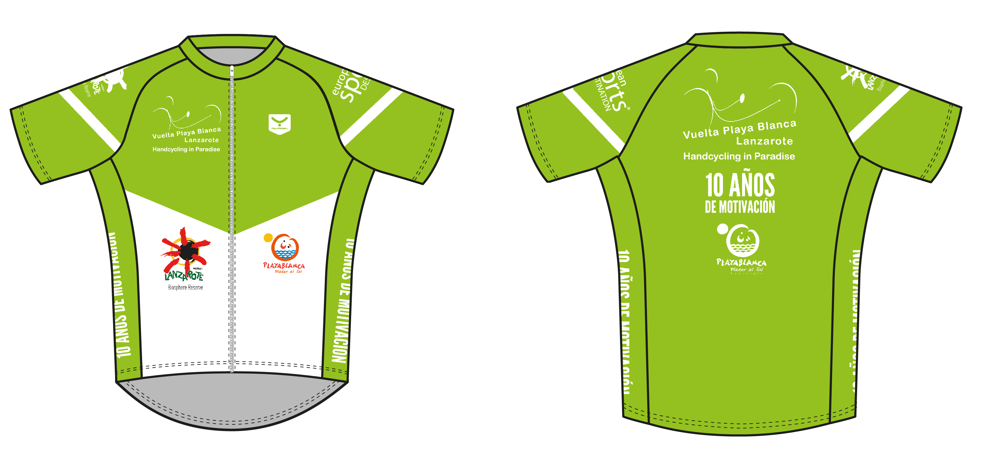

You can Pay at the Event location on 13.Feb.2019 Cash or Bank transfer to Asociación Promoción Turismo y deporte sin Barreras . Bankia: IBAN: ES91 2038 3323 1160 0014 9976 CAHMESMMXXX

Thank you for your Participation
www.vueltaplayablanca.com

Facebook: Vuelta Playa Blanca

More information on: www.trimakina.com

